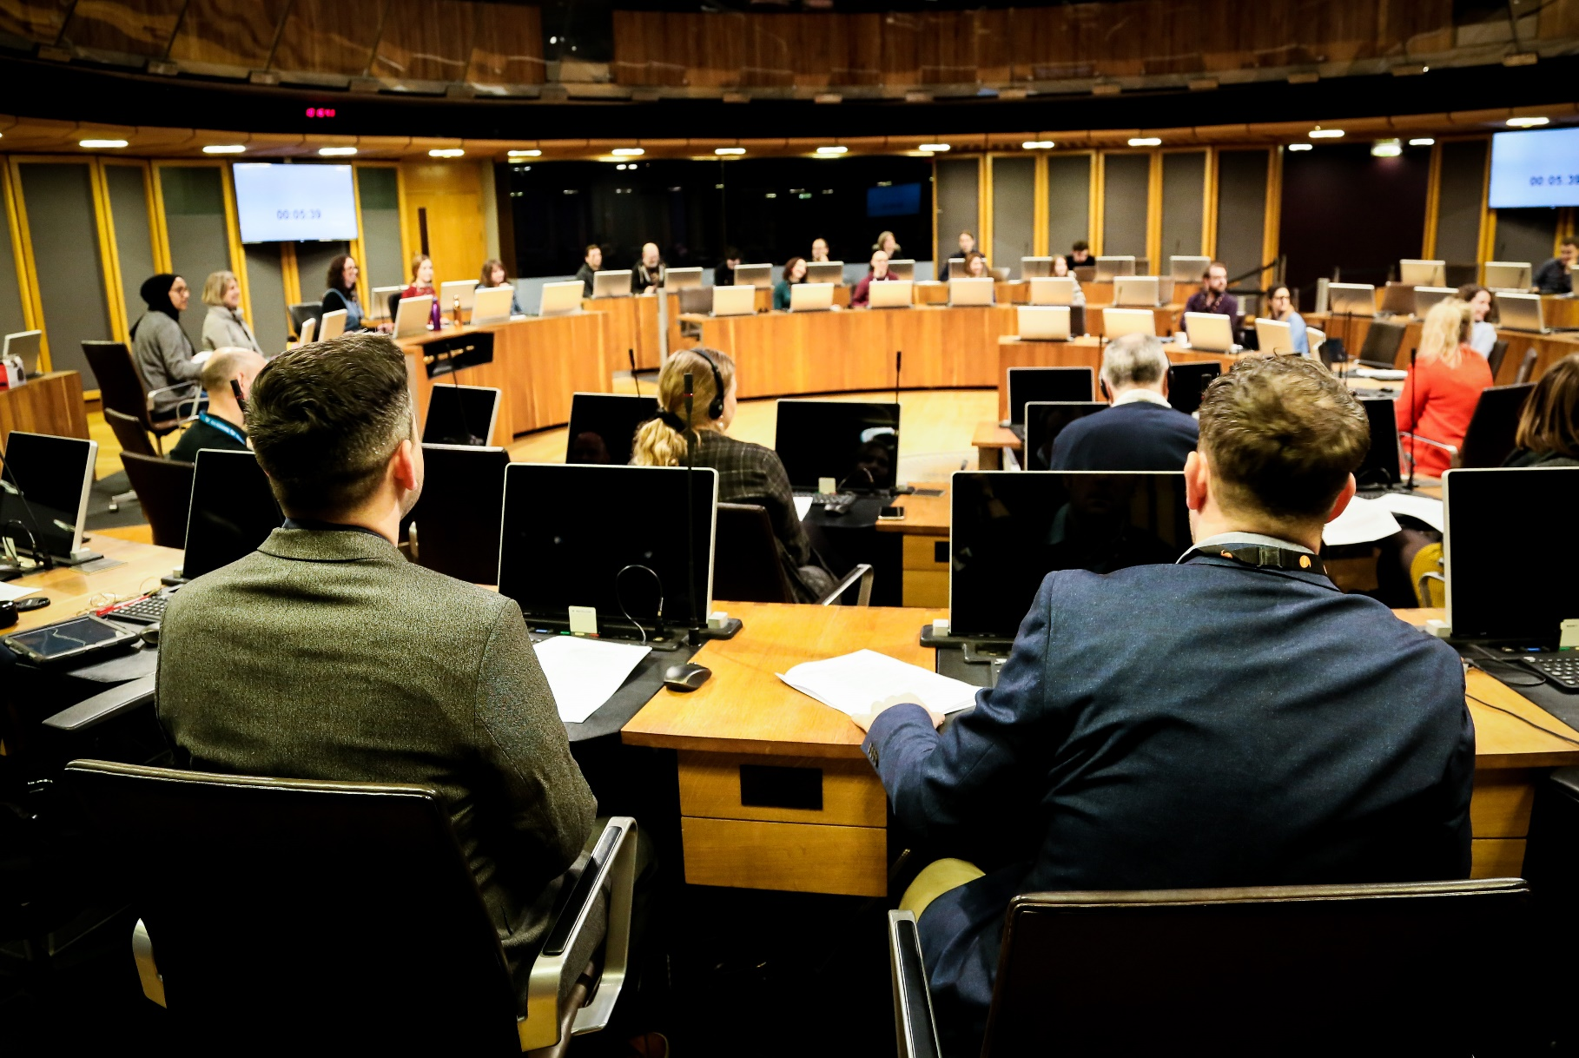

Welsh Parliament

Human Resources

Director of Senedd Business

Candidate Brief

**Contents**

1. **Welcome from Manon Antoniazzi, Chief Executive and Clerk to the Senedd**
2. **The Role of Director of Senedd Business**
3. **About Us**
4. **The Role – Key Objectives**
5. **Person Specification**
6. **How to Apply**
7. **Selection Process**

Croeso/Welcome,

Thank you for your interest in the role of Director of Senedd Business for the Senedd Cymru/Welsh Parliament. The Senedd is at the heart of democracy and politics in Wales. The Senedd Commission’s statutory responsibility is to provide property, staff and services required by the Senedd, to make it an effective parliamentary body that inspires the confidence of the people of Wales.

We are looking to appoint a new Director of Senedd Business who will perform a pivotal role leading up to the Seventh Senedd and beyond. Following the Senedd elections in 2026, we will see a milestone in the Senedd’s history as it expands from 60 to 96 Members. This provides an exceptional candidate with an exciting opportunity to provide the transformational leadership required to lead and continue to enhance our parliamentary business functions through this period of change and transition. The successful candidate will ensure that the current and future needs of the Senedd are met, and exemplary standards of service remain in place.

Joining us at a crucial time to build the foundations for success in the Senedd’s evolution, you will be part of an executive team that has mutual accountability for creating and shaping strategies and implementing these across the Senedd’s operations. You will be working in partnership alongside me and the Director of Resources, the Director of Communications & Engagement and other senior stakeholders including the Llywydd and Senedd Commissioners to deliver our ambitious agenda.

We are seeking a candidate that is used to promoting inclusive work cultures and operating within complex, fast-paced decision-making structures. You will inspire expert, multi-disciplinary teams to continue to perform effectively and provide outstanding parliamentary support in an enlarged Senedd.

We encourage applications from people of all backgrounds and communities. If you feel you can match our level of ambition, we look forward to receiving your application.

More information on the Senedd Commission can be found in our [2023- 24 Annual Report and Accounts.](https://senedd.wales/commission/senedd-commission-publications/annual-reports-and-accounts/annual-reports-and-accounts-2023-24-highlights/)

Manon Antoniazzi  
Chief Executive and Clerk of the Senedd   
Senedd Cymru/Welsh Parliament

The Role

**Job Title**: Director of Senedd Business

**Salary**: £117,918 - £150,484 (SC2)

**Relocation Costs:** up to a maximum of £8,000 may be available.

**Duration:** Permanent

**Directorate**: Senedd Business

**Reporting to:** Chief Executive and Clerk of the Senedd

**Location:** Senedd, Tŷ Hywel, Cardiff Bay/Hybrid

This role is based at the Senedd in Cardiff Bay, but hybrid working will be a feature of the role. An appointment at Director level will necessarily require attendance at the Senedd to support the Chief Executive and the Llywydd based on the various demands of the role and to accommodate business needs. The post holder will be expected to work on-site 3-4 days a week during term time.

**Pattern of Working:**

This is a full-time post although flexible working arrangements will be considered, subject to meeting the needs of the Senedd and its Members.

**Security Clearance:** Successful external candidates will be required to complete pre-employment checks. This includes mandatory national security Vetting to Counter Terrorist Check (CTC) level or Security Check (SC) or higher, as described below.  All successful candidates are required to pass these checks before an offer can be confirmed.

To enable the mandatory national security checks to be carried out you must have resided in the UK for a **minimum** period of time. To undergo a CTC level check, you **must** have normally resided in the UK for a **minimum** of 3 years out of the last 5 years. To undergo a SC level check, you **must** have normally resided in the UK for a **minimum** of 5 continuous years.

If you do not meet the minimum length of stay required for the mandatory national security checks to be undertaken, we are **not** able to move forward with your application.

This position has been assessed as requiring a ‘SC’ level of security check.

# About Us:

The Senedd (Senedd Cymru or Welsh Parliament) is the democratically elected body that represents the interests of Wales and its people, makes laws for Wales (on matters not reserved to the UK Parliament), agrees Welsh taxes and holds the Welsh Government to account. It is a unicameral legislature comprising 60 members. The Senedd is legally separate from the Welsh Government.

At the next election in May 2026, the composition of the Senedd will change. The number of Members will increase from 60 to 96 and they will have been elected by a new system which in itself will bring changes to the way Members approach their work and how the Senedd operates its formal business. We expect constitutional change will continue to have an impact on the demands faced by the Senedd Commission in the coming years.

The Senedd Commission provides the property, staff and services required for the Senedd’s purposes. It may also exercise other functions, such as pay Members’ salaries, allowances and pensions, and promote public awareness of the electoral system and system of devolved government. The Commission comprises the Llywydd (Presiding Officer), and four other Members appointed by the Senedd. The Commission is accountable to the Senedd for the exercise of its functions. This accountability is exercised in a variety of ways, including questions to the Commission for oral and written answer, the Finance Committee’s scrutiny of the Commission’s budget, and scrutiny of the Principal Accounting Officer by the Public Accounts and Public Administration Committee.

In 2025/26 the Senedd Commission will have a budget of around £84.3 million and approximately 530 employees.

The Commission delegates its functions, including its responsibility for the management of staff, to the Clerk of the Senedd, subject to specified exceptions and conditions. The Clerk is the Chief Executive and Principal Accounting Officer of the Commission.

The Executive Board is the strategic decision-making body for all matters delegated by the Senedd Commission. It is also an advisory body to the Senedd Commission, to ensure that it receives the best possible advice in setting the Commission’s Strategy, goals and priorities, the Budget, and in taking decisions. The Executive Board is chaired by the Chief Executive and its membership includes Directors, the Director of Resources, Director of Communications and Engagement, Chief Finance Officer, the Chief People Officer and the Head of Legal Services.

The Leadership Team is an advisory body to the Executive Board and an enabler for the effective delivery of operational plans, priorities and governance arrangements. The Leadership Team is made up of the senior executive team and Heads of Service.

The Commission has appointed independent advisers to ensure that Commissioners and the Senedd’s senior management team are supported and constructively challenged in their roles. The advisers are members of the Commission’s Audit and Risk Assurance Committee and the Remuneration, Engagement and Workforce Advisory Committee.

Members’ salaries and other costs are determined by an Independent Remuneration Board. The Commission has responsibility for ensuring that the Board’s decisions are implemented and to provide for them in its budget. The Chief Executive is responsible for the selection of candidates for appointment to the Board, who are formally appointed by the Commission.

# About the role:

You will work directly with the Llywydd, Senedd Commissioners, Committee Chairs and other senior political stakeholders, including the First Minister, Party Leaders and Government Ministers.

You will also be the Executive Board member responsible for the delivery of outstanding parliamentary and Member-facing support to the Senedd as a whole, its committees and individual members. The role has three elements:

Advisor – as an expert in parliamentary procedure and practice, to provide constitutional and procedural advice to the Llywydd and Members of the Senedd that is reliable, consistent, authoritative, timely and tailored to political circumstances, including on matters that are novel and or/contentious.

Executive – as a member of the Executive Board, to ensure effective, responsive, and well-governed organisational leadership of the Senedd Commission, working as ‘one team’; and

Leader and change manager – the election in 2026 will present a transformational change for the Senedd and in particular the Business Directorate. You will lead the development of a wide range of specialist parliamentary and business support services.

The Director of Senedd Business reports to the Chief Executive.

The Senedd Business Directorate currently comprises around 170 multi-disciplinary staff across five services (divisions): the Legal Service; the Chamber and Committee Service; the Policy and Legislation Committee Service; the Research Service; and the Strategic Transformation Service.

You will need to quickly identify the changing needs of an enlarged Senedd and the impact that will have on our parliamentary services, the staff who deliver them and adapt services accordingly.

The Director also has a representational role, both nationally and internationally, alongside the Llywydd and Chief Executive, on the evolving constitutional framework of the UK and Wales, and new ways of working in light of procedural innovations as a result of an enlarged Senedd.

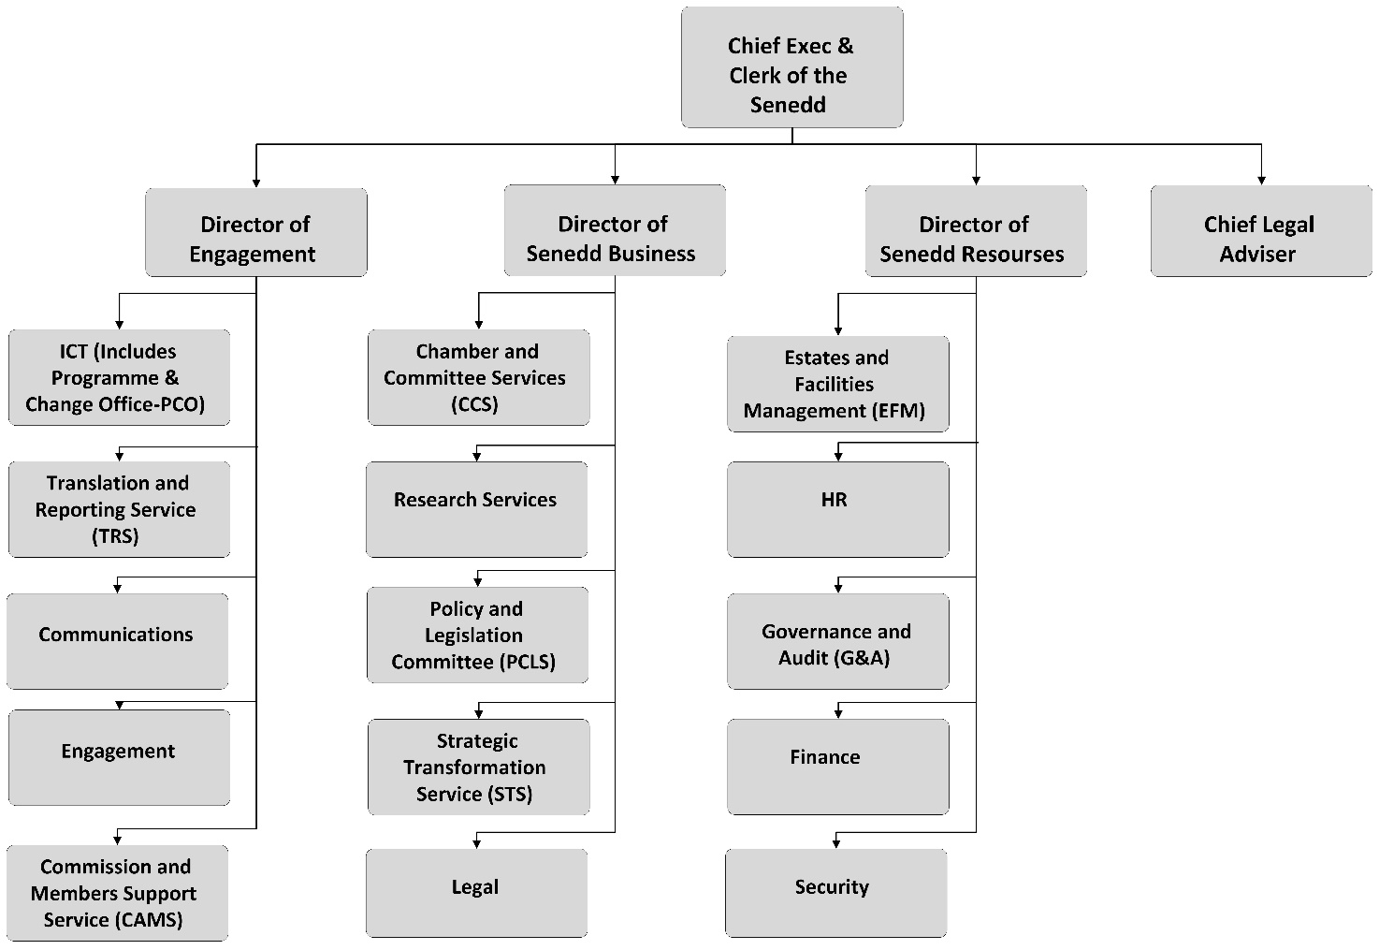

# Role Key Objectives:

* Providing key parliamentary support and constitutional advice to the Llywydd in their role as the Senedd’s ultimate procedural authority, Chair of the Senedd Commission, Chair of the Business Committee and principal representative of the Senedd, in relation to their procedural, legislative and corporate responsibilities.
* Supporting the Chief Executive and Executive Team, working collectively to support the Senedd Commission in establishing their strategic direction and goals and, through organisational leadership, ensuring that those strategic goals are delivered.
* Leading the transformative change necessary across the parliamentary business functions and supporting functions to respond to the enlarged Senedd following the 2026 election, anticipating and re-prioritising Directorate and organisational considerations whilst maintaining a focus on delivery.
* Representing the Senedd at regional, national and international level with key stakeholders, including government bodies, local authorities, agencies, local community, private sector, academic institutions and other organisations. In particular, maintaining strong links with other parliaments in the UK and across the world to benchmark and develop parliamentary services.
* Ensuring that the organisation provides outstanding parliamentary and Member-facing support to the Senedd as a whole and individual Senedd Members, including through the business of the Siambr and Senedd Committees, as well as Independent Remuneration Board secretariat.
* Leading by example to further a culture of collaboration between Senedd Business Directorate staff and staff within other directorates to maximise the efficiency and coherence of the service Senedd Members receive identifying the opportunities that the constitutional changes bring after the election.
* Leadership of the delivery, and continued development of specialist parliamentary support to ensure the parliamentary business of the Senedd operates effectively.
* Strategic and corporate senior leadership of Senedd Business Directorate staff, recognising the challenges and opportunities afforded by the enlargement of the Senedd, ensuring the team has the right organisational structure, professional skills and capabilities, effective capacity planning, and appropriate governance – including robust development and investment plans for the future.
* Ensuring staff are motivated, developed and capability is enhanced so that individual and collective performance meets the needs of the Senedd Commission, and that Senedd Members receive world-class, proactive, flexible, expert support to enable them to do their jobs to the highest possible standards.

# Job Specific skills and Competencies:

This section states the skills and experience deemed to be essential or desirable for this role. You should refer to these in your covering letter.

## Job Specific criteria:

1. Significant, experience of providing expert, impartial parliamentary and procedural advice at Executive level in a legislature/parliamentary organisation or equivalent.
2. Highly developed strategic capability, with proven ability to manage change successfully, combined with the ability to maintain a sound grip of potential risks, financial and performance standards.
3. Demonstrate significant experience of working in a senior role in a political environment with evidence of the ability to challenge and negotiate with a complex range of internal and external stakeholders to achieve beneficial outcomes for the people of Wales.
4. Demonstrate a collaborative leadership approach that encourages a “one team” ethos across the organisation and delivers innovation and continuous improvement through high performing, motivated teams.
5. An effective communicator and passionate advocate for the organisation and its role within Wales and beyond, with the ability to build trust in a political environment.

**Desirable**

1. Enhanced understanding of the Senedd, Welsh Government and the wider public services in Wales and the political, constitutional and cultural context within which they operate.

## Welsh language criteria:

The language skills for this post have been assessed Courtesy Level Welsh.

Candidates should have the ability to:

* Pronounce Welsh names, answer the telephone, greet people or make introductions bilingually.
* Understand and use proactively familiar, every day, expressions.
* Understand very short texts where people are giving basic information about themselves or others in correspondence, on forms or to interpret content using the technology available.

If the successful candidate does not possess these skills, they will be expected to commit to learn them during an agreed period.

For further information on the Welsh language levels, please [**visit our website.**](https://senedd.wales/commission/work-for-the-senedd-commission/official-languages-and-recruitment/)

## Level Competency Areas and Behaviours:

These are the specific competencies that you will be expected to demonstrate in this role. You are encouraged to refer to these in broad terms in your covering letter.

**Leadership**

* Proven experience in a senior leadership role with the ability to manage significant organisational change, motivate and develop high-performing teams and operate collegiately across the organisation and as part of the Executive Board.
* A visible leader who inspires trust, takes personal responsibility for delivering results, managing risks and budgets effectively and matches resources to business priorities to achieve efficiency and value for money.
* A leader with strong relationship skills who understands and is sensitive to the impact of change on both internal and external stakeholders in a high pressure, political environment.
* Someone who encourages an evidenced based approach to problem solving and a critical evaluation of current approaches and processes to deliver high levels of performance and continuous improvement.

**Strategic thinking**

* Ability to make a strong and constructive contribution to strategic planning and problem solving at board level, anticipating and influencing future priorities.
* Understands the Senedd’s priorities, wider policy environment and institutional constraints, and can translate these into an overall strategic direction for the Commission and its services.
* Can identify tensions, dependencies, set priorities and make trade-offs between different priorities and over different timescales.

**Communications**

* Experience of handling difficult, sensitive and high-profile issues, with integrity and authority including scrutiny by the media, public or stakeholders.
* The ability to listen and communicate effectively to deliver effective engagement with internal and external stakeholders and encourage greater understanding of and support for the organisation’s objectives.
* Be fully committed to the Senedd’s Official Languages Scheme and the delivery of exemplar bilingual services, positioning the Senedd as a truly bilingual institution and ensuring the opportunity to communicate in Welsh is available to all.

**Working with and Valuing Others**

* Provide strong and inspirational leadership, promoting a culture of high performance through effective collaboration, continuous improvement and innovation.
* Creates a culture of optimising resources, ensuring fair and transparent approaches to talent management and resourcing decisions that promotes inclusivity and diversity.
* A positive ambassador for the organisation, working effectively with and through stakeholders and partners to ensure buy in to the organisation’s vision, purpose and strategic objectives.
* A reputation for impartiality and integrity and a commitment to ensuring that services are delivered professionally, effectively and without favour.

**Learning and Improving**

* Flair, creative thinking and the ability to manage significant change and considered risk inclusively.
* A champion for inclusion who creates a culture of open communication in delivering change and promotes opportunities for contribution at every level of the organisation.
* Demonstrates strong intellectual and analytical capability that encourages a culture of evidenced based decision making.
* A highly flexible, adaptable and empathetic approach to all aspects of the role;
* Demonstrates courage, integrity and personal accountability in delivering the role and in leading teams.
* Encourages ongoing professional development of staff to support continuous improvement within the organisation.

**Delivering Results to our Customers**

* Putting customers at the heart of everything we do and providing imagination and flexibility in service development, with the aim that all who use Senedd services are delighted with the result.
* Commitment to provide proactive and agile support services for all Senedd Members and their support staff.

## Application Process

|  |
| --- |
| * Please apply by submitting a CV, and a supporting statement which outlines your motivation for applying for the role and how you meet the person specification (no more than 2 sides of A4 in length). Please ensure that you address the key requirements set out in the specification. * Please provide details of two referees (one should ideally be your current employer) - we will only approach referees with your permission and if you are shortlisted. * Please complete the Equal Opportunities monitoring form when you upload your details. We are keen to ensure that all our jobs are accessible to all members of the community and use this data to   monitor our progress in achieving this.   * Please make sure your application is submitted by 11 May 2025 as stated below to fizza.islam@LHH.com   For a confidential informal discussion about the role, please contact our recruitment partners Penna LHH on 0141 220 6460 or [fizza.islam@LHH.com](mailto:fizza.islam@LHH.com) |

## Recruitment Timetable

|  |  |
| --- | --- |
| Application closing date | 11 May 2025 |
| Preliminary interview for longlisting candidates | Week commencing 19 May |
| Shortlisting | Week commencing 26 May |
| Final interviews | Week commencing 9 or 16 June |

**Diversity and Inclusion**The recruitment will be undertaken in accordance with equal opportunities principles – this means that everybody should have the same opportunities based on their ability, qualifications and suitability for the role.

We therefore welcome applications from all sections of the community, regardless of age, gender, ethnicity, sexual orientation, faith or disability, from all backgrounds and with many different skills, experience and perspectives. We particularly encourage applications from disabled people and people from ethnic minority backgrounds.   
  
All appointments will be made on merit following a fair and transparent process.

**Disability Confident**We are proud to operate under the Disability Confident Employer Scheme whereby we guarantee an interview for disabled applicants if they meet the minimum essential requirements for the role. By ‘minimum criteria’ we mean that you must provide us with evidence in your application which demonstrates that you generally meet the level of competence for the role and any qualifications, skills or experience defined as essential.

**Working at the Senedd**

The Senedd is an exciting place to work. We have progressive policies and a commitment to training and development.

When you work here, you’re entitled to:

Note – Pro rata will apply for part time employees

|  |  |
| --- | --- |
| * 31 days annual leave per year * 11 days Public and Privilege holidays per year | * Incremental pay rise * Principal Civil Service pension scheme |
| * Access to occupational health * Access to Employee Assistance Programme * Supportive workplace equality networks | * Family friendly policies, including career break, part-time working, job share, term time working and special leave * Generous maternity, foster, adoption, and shared parental leave |

# Our Values:

Our values are part of everything we do. Together, we’ve created a set of values that celebrate the way we work together and remind us of who we are and what we stand for. 

|  |  |  |
| --- | --- | --- |
|  |  |  |
| RESPECT  We are inclusive, kind, and value each other’s contributions in delivering excellent services | **PASSION**  We are purposeful in our support of democracy and pull together to make a difference for the people of Wales | **PRIDE**  We embrace innovation and celebrate our achievements together as a team |
| WE ARE ONE TEAM | | |

We look forward to seeing how your values align with ours, so you can help nurture a positive and inclusive culture with us.

# Our official languages (Welsh and English):

We are fully committed to continuously enhancing and improving our exemplary bilingual services and to being a truly bilingual organisation so that Members of the Senedd, the public and staff can choose to work or communicate naturally in either or both of our official languages, with the use of both languages proactively encouraged and facilitated.

Though we do not require all our staff to be fluent in both our official languages, our expectation is that they are all committed to the delivery of services in both our official languages. To that extent, we expect all Senedd appointees to have, or to acquire during an agreed period, courtesy-level skills in Welsh. All posts are assessed in the context of the service area’s ability to deliver bilingual services to our customers and some posts, therefore, require a higher level of Welsh to facilitate that, such requirements are expressed above.

Diversity and Inclusion:

We want to foster an inclusive organisational culture, attracting and retaining the widest range of talent and ensures that all our employees realise their full potential, irrespective of their background. We want our workforce to be more representative of all sections of society at all levels in the organisation.

We welcome applications from a diverse range of people, from all backgrounds and with many different skills, experience and perspectives. We particularly encourage applications from disabled people and people from Black, Asian and Minority Ethnic backgrounds, who are currently under-represented in our workforce. Find out more about our approach to diversity and inclusion [on our website](https://senedd.wales/commission/work-for-the-senedd-commission/diversity-and-inclusion-at-the-commission/).

All appointments are made on merit.